Google Professional Analytics - Capstone Project

Case study: How does a bike-share navigate its speedy success?

By Jackson Wu

### Scenario/Introduction:

Cyclistic* is a bike sharing company that was launched in 2016, the company has since then grown its service to 5,824 bicycles that are geotracked and locked into a network of 692 stations across the city of Chicago. Its bikes can be unlocked from one station and returned to any other station in its system nytime.

Cyclistic’s marketing strategy so far has relied on building general awareness and appealing to broad consumer segments. One of the marketing approaches has been offering flexibility of its price plans: single-ride, full-day passes, and annual membership. Customers with single-ride or full-day passes are referred to as “casual riders”, while annual membership owners are “members”. Director of marketing, Lily Moreno, believes maximizing the number of annual members will be key for future growth of the company, the financial analysts of the company have stated that the annual members are more profitable than casual riders, but the flexibility of the single- and full day pass helps to attract new customers. Rather than targeting all-new customers, Moreno wants to create a marketing strategy that converts casual riders to annual members as she believes there is a good chance of converting casual riders into members.

Our job is now to analyze the data and help the involved stakeholders to understand how casual and annual members use Cyclistic differently, as well as try to understand why casual members might want to upgrade to an annual membership and how the company can use digital media to influence casual riders into converting into an annual membership.

### Business Tasks:

* Analyze how casual and annual members use the service differently?
* Why would a casual rider want to upgrade to an annual membership?
* How can the company use digital media to influence casual riders into upgrading to an annual membership?

## Prepare/Process data:

Cyclistics historical trip data (last 12 months) was provided and we will use this to analyze and identify trends. The dataset contains de-identifiers such as rider id, rideable_type, start & end time, start & end station and their corresponding station id, name, geographical coordinates (longitude and latitude) and lastly member type.

Due to the large size of the data, we will use R for cleaning, analysis and visualization of the data.

You can find the code for the analysis in the github repository.

## Key findings:

By using R, we get the following plots that might help our analysis.

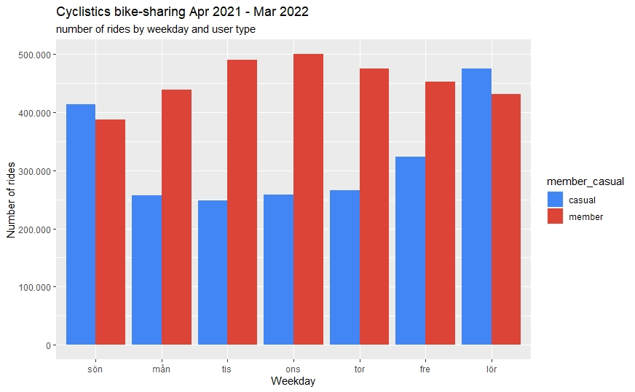

# 

In the barchart generated by our datasets in R, we can see that when a customer is a “member”, i.e customer with annual membership pass, uses the company’s bike sharing service at greater frequency than casual customers. But interestingly, the casual customer tends to have a longer average usage duration of the bikes, based on the data for the past 12 months.

Frequency of the service tends to increase towards the end of the week among casual users, as well as the average duration during these days, in fact, casual member’s average ride time over this 12 month period is 85% longer than member type customers.

In general, for both casual and member type customers, they tend to choose to ride the classic bike rather than the electric bike. Our data shows that 56% of casual customers tends to select the classic bike, and 62% of member customers uses the service with classic bike.

## Recommendation:

The company should look into creating an annual membership of at an lower price tier to try to convert casual users to become members, the data suggest that casual riders uses the bike sharing service mostly towards the end of the week, and when they do, they tend to ride longer than already member-type users, by creating a lower tier annual membership, it could give casual users a reason to buy the annual membership without feeling “not getting their bang for the buck”, as there could be a breaking point where customers are still paying for single rides/passes but then realize that multiple single ride/pass is somehow more expensive than an annual membership, especially if the frequency and duration of their rides hasn’t changed dramatically.

They could also create an entire new pass, one that only works during fri-sun, to cater more towards casual customers, and if this were the case, the company can use digital media to showcase and promote the flexibility of the different types of passes. One can be very flexible and only single ride/day passes, but now there is also flexibility for long term memberships.